Synergism

Iteration 02

2019-03-09

ABJ Software Solutions

Alyssa Jia 300261497

Bogdan Bielka 300281578

Jonah Roesler 300279311

Supervisor: Rahim Virani

Team Leader Jonah Roesler

## Iteration 02 Project Initialization and common bug fixes Doc By Jonah

ABJ Softsol

Synergism Project Initialization doc

ITERATION 02

Jonah Roesler

When getting the Iteration 02 to work you need to be able to have both

1. Apache server

2. Mysql server (on wamp or mysql server, etc)

Start by

Making sure your JRE is 1.8 and your workspace JRE is also 1.8

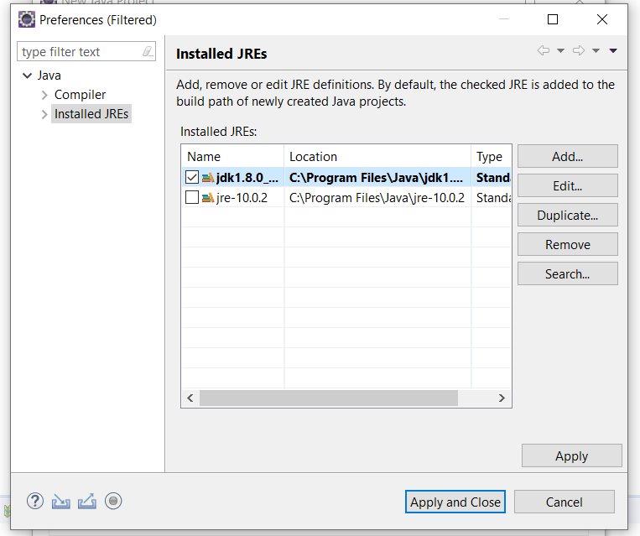

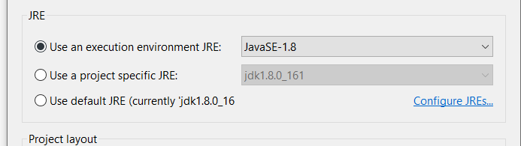

After you create a project, use git to pull Iteration02  
After **git pull origin Iteration02** there will be some errors

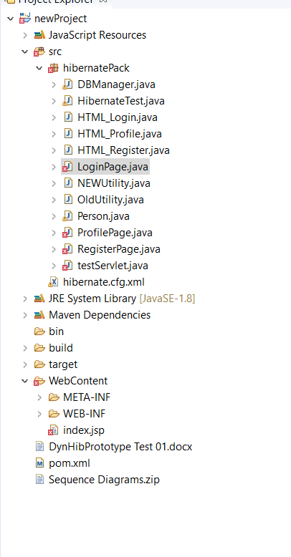

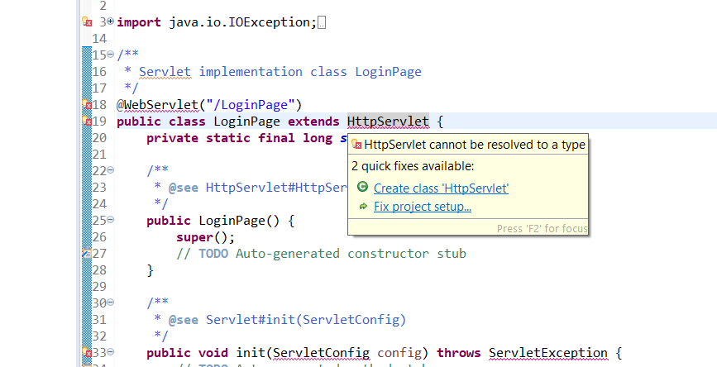

BEFORE fixing this make sure you add the apache server

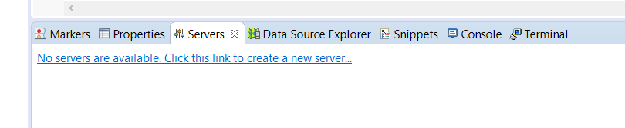

Add the apache server and point it to your apache tomcat installation directory

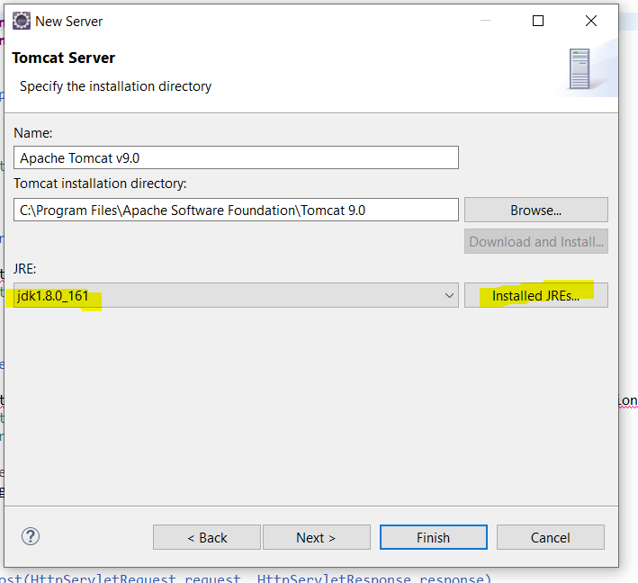

Make sure the server JRE matches your project JRE (JDK 1.8), and that if it is set to “workbench default JRE” that your workbench default JRE is set to the correct JDK 1.8

After if you still have your errors like pictured below here you can Choose fix project setup OR right click on project and hit “build path”



Inside the buldpath hit “Add Library” and doubleclick “Server runtime”  
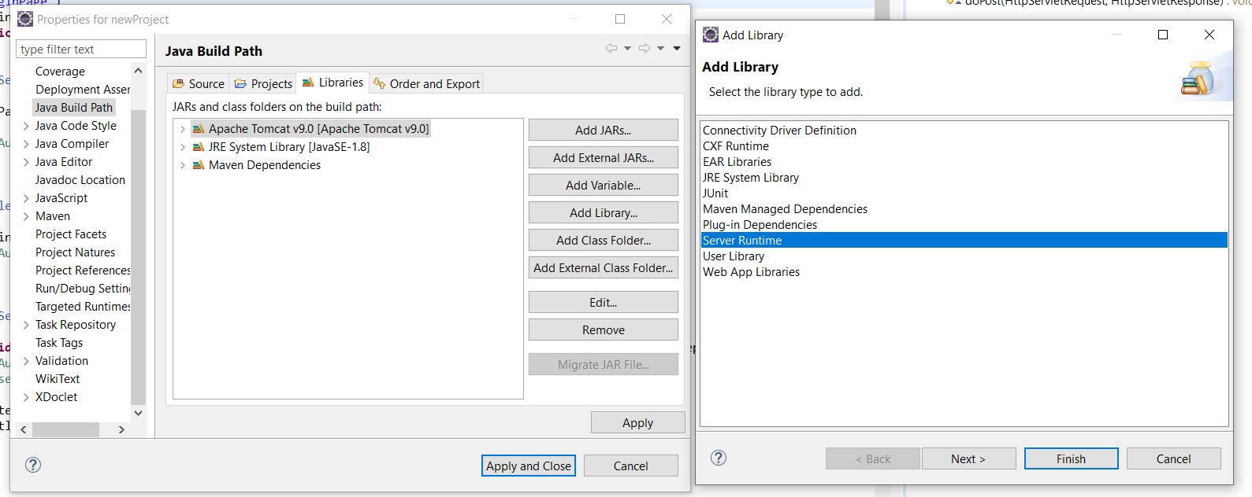

You will see a selection of server runtimes to add, choose your Tomcat Server

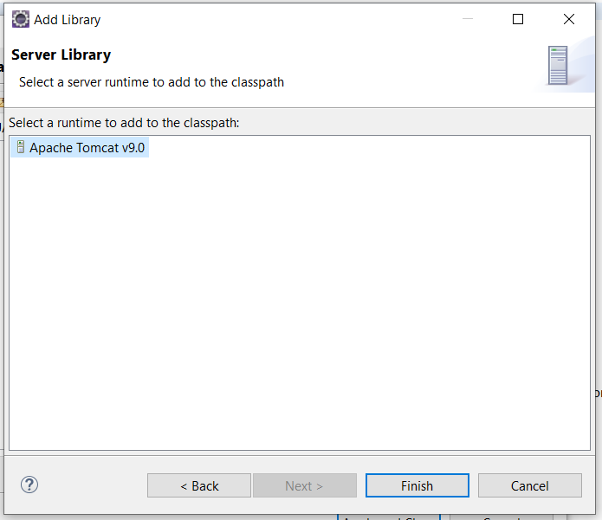

You may also have an “Servlet library not found” error in your index.jsp file  
If so you can add another library called “Web app libraries” to fix this  
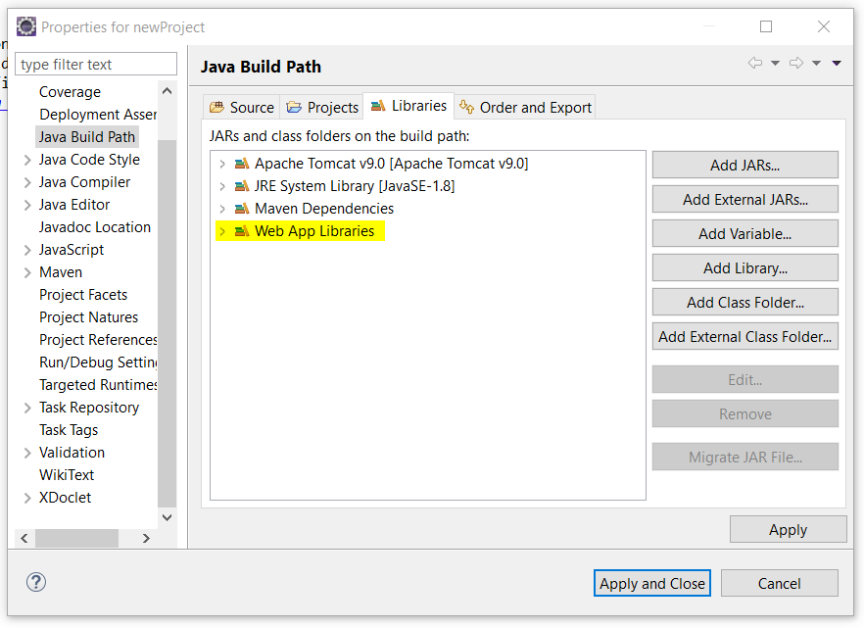

With no more errors it seems you are ready to test run the server  
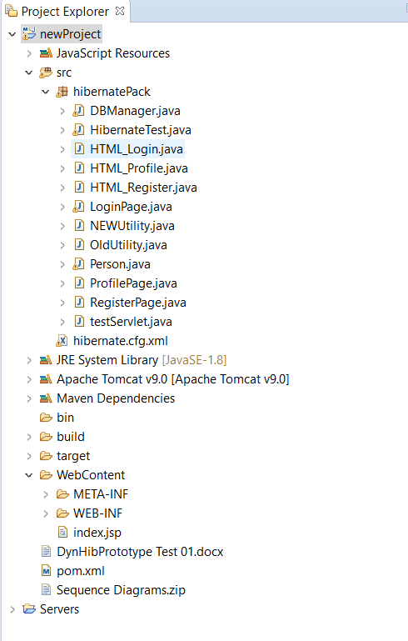  
  
 but not yet, there is still one problem, the run on server option isnt there.

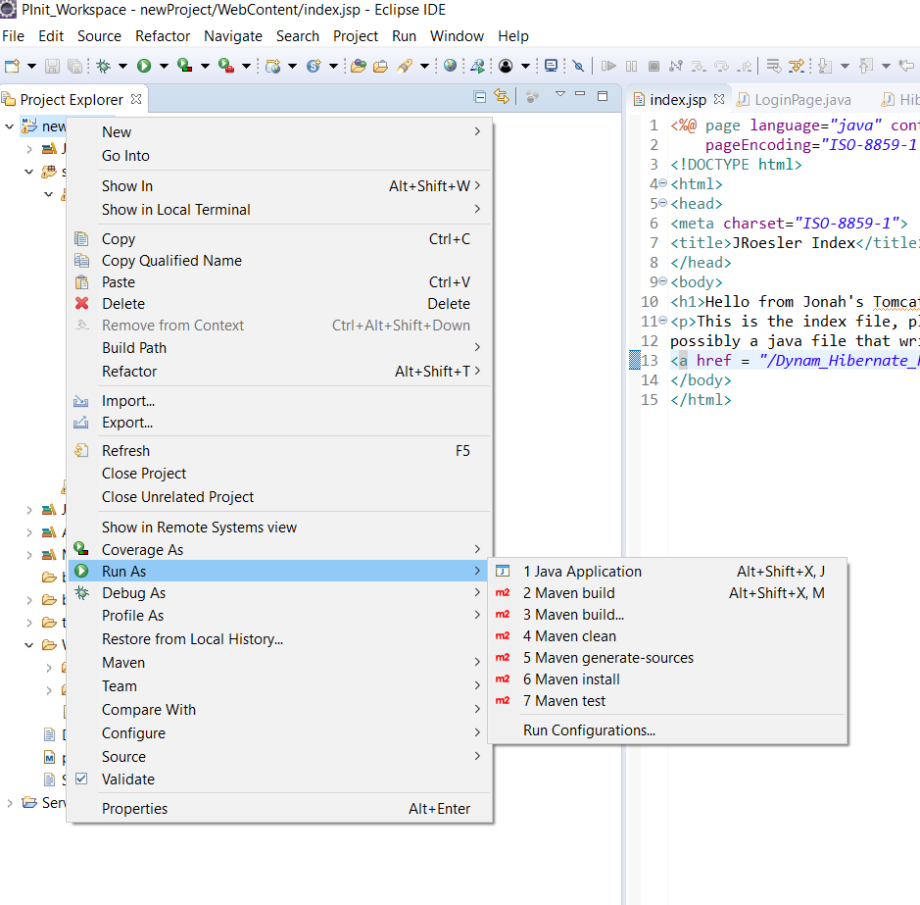

To fix this, right click on project >properties>project facets and turn on “Dynamic Web Module”  
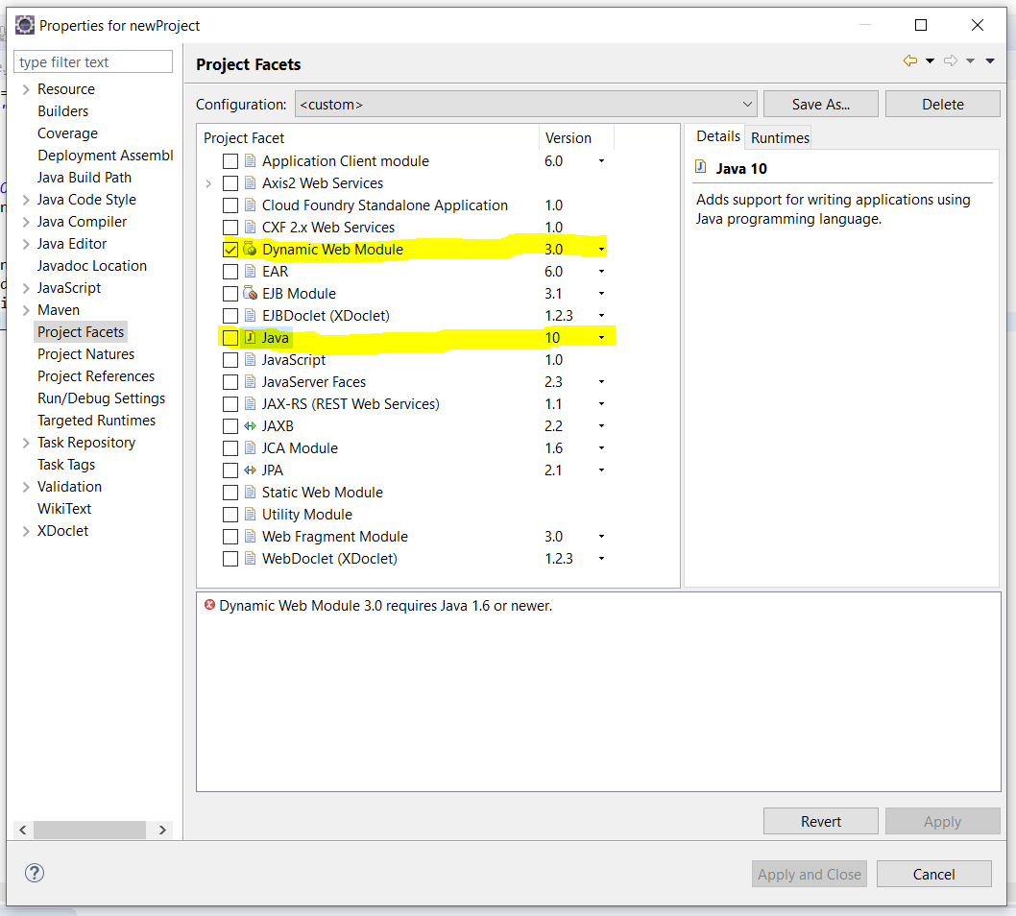

Java may complain at you but you can see here this is once again because they gave us the wrong java version! **Change it to 1.8 or your server may refuse to run your project**

When the server refuses to run your project because it is on the wrong version it will look like this, your project should be available here in the “configured” section  
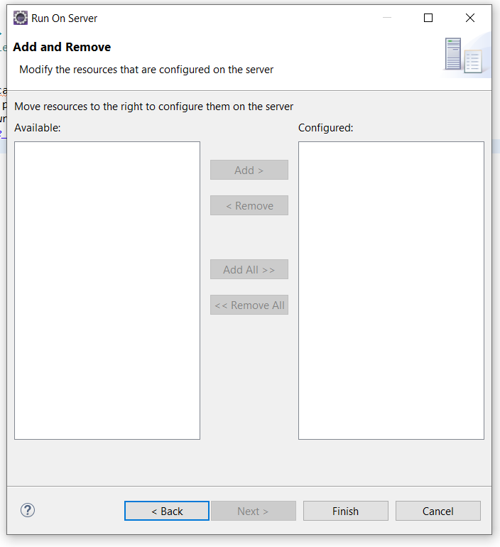  
Here is the error you will receive  
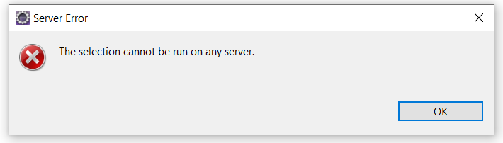  
  
With the proper configuration here we see our *newproject* when setting it to run in the server  
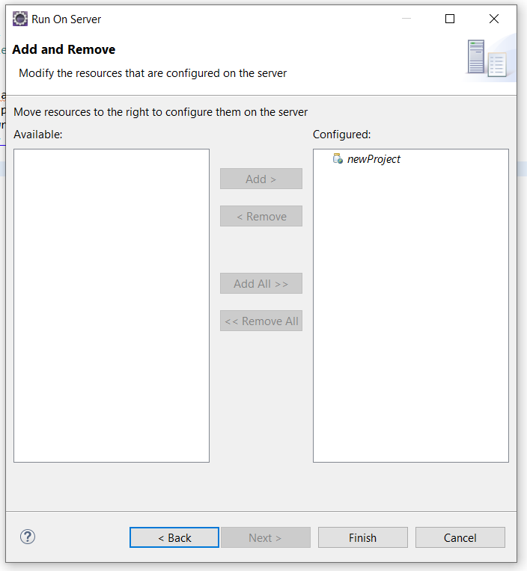

Everythin’s good so far now!  
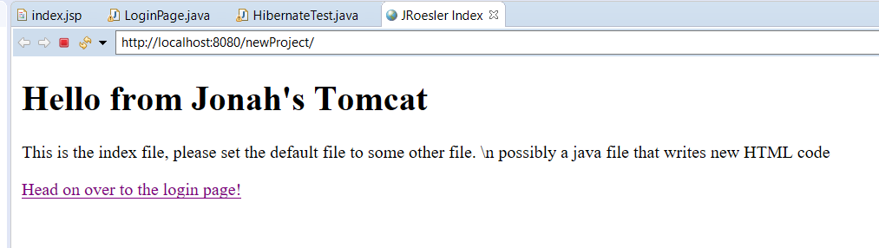

Except for this

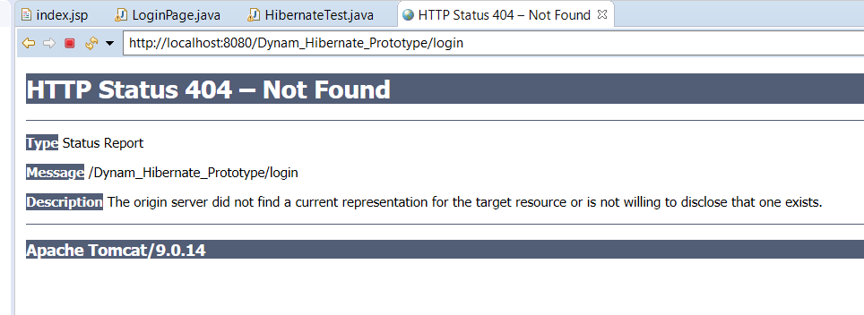

However, if you go back to the original page and type /login after the URL it works! Why is this?  
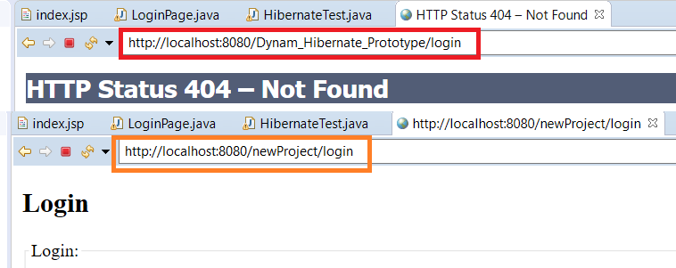  
  
This is because the old links in our index and HTML pages are set to the original project name that i made for **Iteration02** instead of our *newProject* (or whatever your project name is on your computer), and may need to be updated  
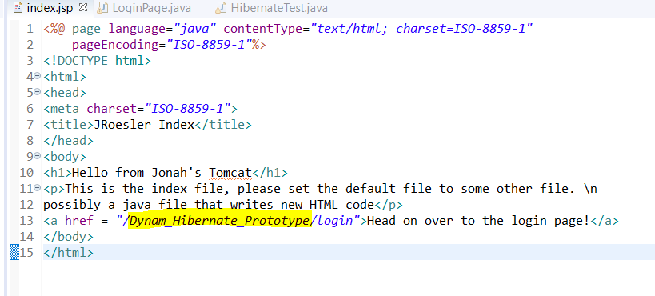

You can either refractor your project name, or update the links  
I decided to refractor mine here to **Dynam_Hibernate_Prototype** and it works

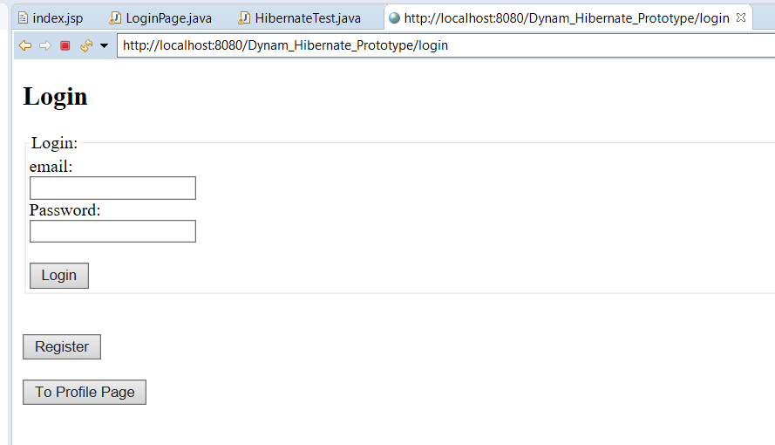

**NOTE: another important link is this one here inside the *hibernate.cfg.xml***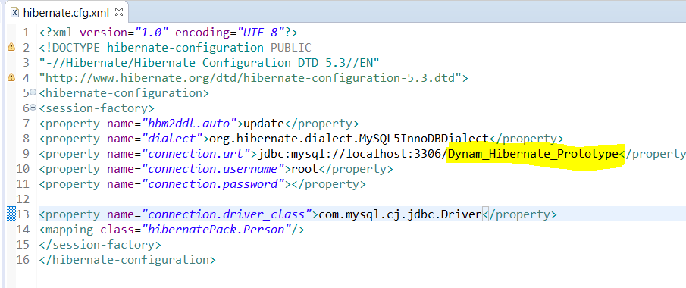

It is mapped to your mysql database name **not** your project name. **Make sure to make it match your database name or you will get an error**

The error likely will look like this  
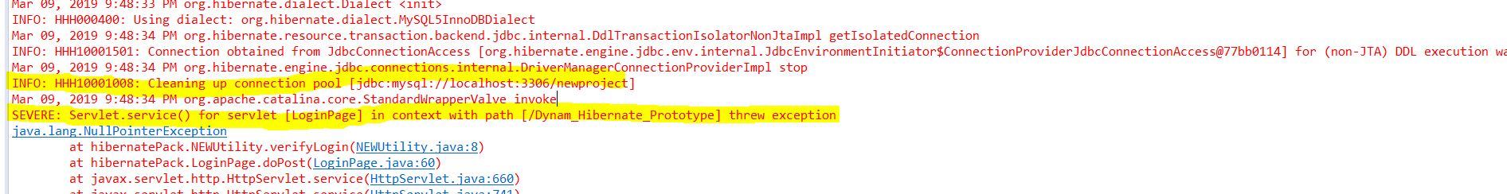

Next step is start up WAMP or your Mysql of choice

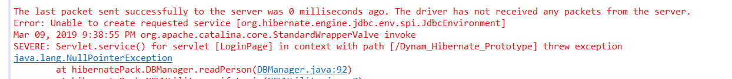  
This error is from not having mysql running on my computer

IF you put a password or something on your mysql meaning that you must input that password when you type *“mysql -u root -p”* then that password **must be present here in the hibernate config**  
Similarly if you use a different user than root user the “username” property should be changed to match it  
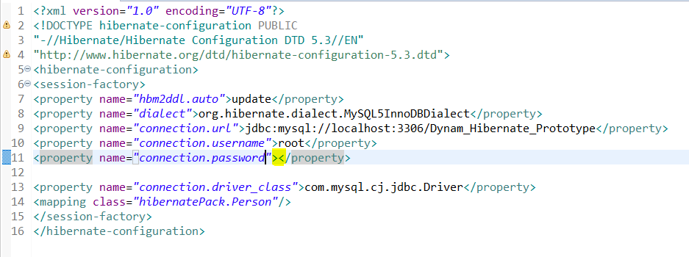

Once inside the program you should now be able to run all functions assuming you have a PERSON table inside the database  
**IF you do not then a person table must be created in the database by first going to the register page and registering a person. This will create the person table inside the database allowing you to log in**

If everything goes well you should be able to login and head to the profile page no problem

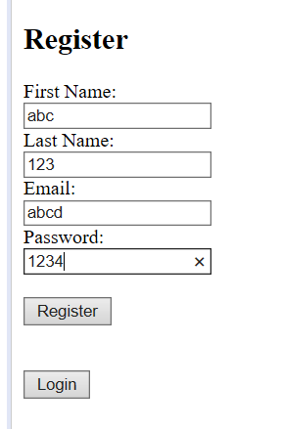

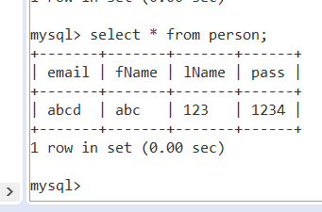  
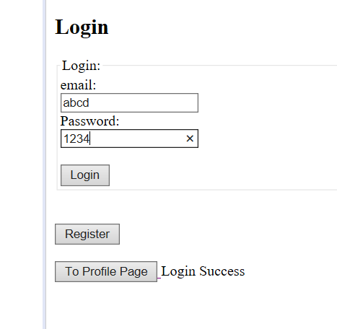  
  
Currently profile page is not done yet, this is done as a test to make sure the profile page can pull the data from mysql.  
